Developed by Virus5600  
Twitter: [@SatchNavida](https://twitter.com/SatchNavida)  
Reddit: [u/SatchTFF](https://www.reddit.com/user/SatchTFF)  
Facebook: <fb.me/virus5600>  
Github: <github.com/virus5600>

TABLE OF CONTENTS

**INTRODUCTION** . . . . . . . . . . . . . . . . . . . . . . . . . . . . . . . . . . . . 2  
 Description  
 Basic Information  
 Installation

**CONTENTS** . . . . . . . . . . . . . . . . . . . . . . . . . . . . . . . . . . . . . . . 3

**INTRODUCTION**

**Description:**

Defensive Add-on is an add-on that allows players to place defensive turrets and traps to protect themselves, their creations, positions, and so on. The add-on adds ***Towers***, ***Traps***, ***Entities***, ***Structures***, ***Villager Types***, and ***Items*** to the game, which opens a lot of new capabilities, ideas, and creative imaginations for the players to explore.

**Basic Information:**

Author: Satch Navida (Virus5600)  
Minimum Required Game Version: 1.16.100  
Add-on Version: 1.0.0  
Dependencies: Defensive Measures (RP)  
Compatible with: Majority of add-ons.

**Installation:**

To install the Add-on, please follow the instructions provided below:

**<WINDOWS 10>** For windows 10, simply double click the **“*mcpack*”** file and wait for Minecraft Win10 to load it.

When using the behavior pack in a world, **enabled** the “Holiday Creator Feature” to be able to use the add-on.

**<ANDROID>** Currently unknown…

**CONTENTS**

**Turrets:**

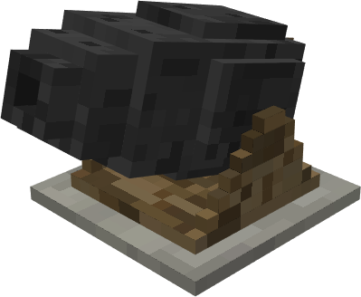**Cannon** Turret - The very first turret implemented in the add-on. It shoots cannonballs that explodes upon impact.

Damage:   
Attack Speed: 0.2 shots/s  
Health: 50 (C:\Users\karls\AppData\Local\Microsoft\Windows\INetCache\Content.Word\heart icon (full).png * 25)  
Repairable: YES  
Repair Items: [Wood Plank, Iron Nugget, Iron Ingot, Iron Block]  
 > Wood Planks: +1 ()  
 > Iron Nugget: +1 (C:\Users\karls\AppData\Local\Microsoft\Windows\INetCache\Content.Word\heart icon (half).png)  
 > Iron Ingot: +10 (C:\Users\karls\AppData\Local\Microsoft\Windows\INetCache\Content.Word\heart icon (full).png * 5)  
 > Iron Block: +100 (C:\Users\karls\AppData\Local\Microsoft\Windows\INetCache\Content.Word\heart icon (full).png * 50) & Absorption 3/+6 ( * 3)

